**2050. Parallel Courses III: -**

Hard Accepted: 42.9K Submissions: 65.6K Acceptance Rate: 65.4%

You are given an integer n, which indicates that there are n courses labeled from 1 to n. You are also given a 2D integer array relations where relations[j] = [prevCoursej, nextCoursej] denotes that course prevCoursej has to be completed **before** course nextCoursej (prerequisite relationship). Furthermore, you are given a **0-indexed** integer array time where time[i] denotes how many **months** it takes to complete the (i+1)th course.

You must find the **minimum** number of months needed to complete all the courses following these rules:

* You may start taking a course at **any time** if the prerequisites are met.
* **Any number of courses** can be taken at the **same time**.

Return *the****minimum****number of months needed to complete all the courses*.

**Note:** The test cases are generated such that it is possible to complete every course (i.e., the graph is a directed acyclic graph).

**Example 1:**

**Input:** n = 3, relations = [[1,3],[2,3]], time = [3,2,5]

**Output:** 8

**Explanation:** The figure above represents the given graph and the time required to complete each course.

We start course 1 and course 2 simultaneously at month 0.

Course 1 takes 3 months and course 2 takes 2 months to complete respectively.

Thus, the earliest time we can start course 3 is at month 3, and the total time required is 3 + 5 = 8 months.

**Example 2:**

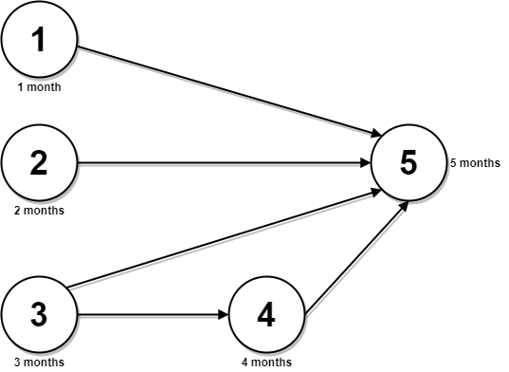

**Input:** n = 5, relations = [[1,5],[2,5],[3,5],[3,4],[4,5]], time = [1,2,3,4,5]

**Output:** 12

**Explanation:** The figure above represents the given graph and the time required to complete each course.

You can start courses 1, 2, and 3 at month 0.

You can complete them after 1, 2, and 3 months respectively.

Course 4 can be taken only after course 3 is completed, i.e., after 3 months. It is completed after 3 + 4 = 7 months.

Course 5 can be taken only after courses 1, 2, 3, and 4 have been completed, i.e., after max(1,2,3,7) = 7 months.

Thus, the minimum time needed to complete all the courses is 7 + 5 = 12 months.

**Constraints:**

* 1 <= n <= 5 * 104
* 0 <= relations.length <= min(n * (n - 1) / 2, 5 * 104)
* relations[j].length == 2
* 1 <= prevCoursej, nextCoursej <= n
* prevCoursej != nextCoursej
* All the pairs [prevCoursej, nextCoursej] are **unique**.
* time.length == n
* 1 <= time[i] <= 104
* The given graph is a directed acyclic graph.

**Code: -**

class Solution {

public:

    int helper(vector<int> &maxtofinish, vector<int> parent[], vector<bool> &vis, vector<int> &time, vector<int> &dp){

        // base case

        if(maxtofinish.empty())

            return 0;

        // recursive case

        int maxtime = 0;

        for(auto &i : maxtofinish){

            if(vis[i] == true and dp[i] != -1)

                maxtime = max(maxtime, dp[i]);

            else{

                vis[i] = true;

                dp[i] = time[i-1] + helper(parent[i], parent, vis, time, dp);

                maxtime = max(maxtime, dp[i]);

            }

        }

        return maxtime;

    }

    int minimumTime(int n, vector<vector<int>>& relations, vector<int>& time) {

        vector<int> parent[n+1];

        vector<bool> vis(n+1, false);

        vector<int> maxtofinish, dp(n+1, -1);

        for(auto &v : relations){

            parent[v[1]].push_back(v[0]);

            // v[0] has child v[1]

            vis[v[0]] = true;

        }

        for(int i = 1; i <= n; ++i){

            // vis[i] = false = has no child

            if(!vis[i])

                maxtofinish.push_back(i);

            // changing all, for fresh use of vis, in topo sort function

            vis[i] = false;

        }

        int ans = 0;

        for(auto &i : maxtofinish){

            vis[i] = true;

            ans = max(ans, time[i-1] + helper(parent[i], parent, vis, time, dp));

        }

        return ans;

    }

};

**T.C: - O(N)**

**S.C: - O(N2)**